**Exercise one**

**A Comprehensive Analysis of Company Objectives and Their Significance**

**Introduction**

The guiding principles of a company determine its strategic direction and decision-making processes. These encompass various dimensions such as profit maximization, sustainable growth, customer satisfaction, social responsibility, innovation, employee well-being and quality. The main objectives of a company, offering insights into their significance would be critically analyzed.

**Profit Maximization:** Profitability is essential for the sustainability of a business and its capacity to reinvest in growth and innovation (Parnell, 2019). Consider Apple Inc., a prime example of a company that consistently achieves remarkable profit margins. Through the design and marketing of premium products, Apple prioritizes profit maximization and, in doing so, sustains its competitiveness in the global market.

**Sustainable Growth**: Sustainable growth is another pivotal objective for firms. This goes beyond mere expansion to focus on the long-term viability of the organization. Amazon is a remarkable case in point as they continually invest in logistics, infrastructure and technology to ensure sustainable growth (Stone, 2020). Their willingness to forgo immediate profits in favor of long-term success demonstrates the significance of this objective.

**Customer Satisfaction and Loyalty**: Prioritizing customer satisfaction and loyalty is crucial for companies. Zappos, an online shoe and clothing shop has exemplified this objective in its business model (Edmondson, 2010). By delivering exceptional customer service, offering free shipping and returns and exceeding customer expectations. Zappos has fostered a loyal customer base that contributes to its long-term success.

**Social Responsibility**: The focus on social responsibility is increasingly important for companies in today's world. Google, the technology giant is not only committed to organizing the world's information but also to making a positive impact on society (Google, 2023). Their dedication to sustainability includes plans to operate entirely on renewable energy. This objective aligns with the values of many consumers driving them to choose socially responsible companies.

**Innovation and Adaptation**: These are imperative for companies to stay competitive in a rapidly changing business environment (Dobbs, 2018). Tesla led by Elon Musk, emphasizes innovation in electric vehicles, renewable energy solutions and autonomous driving (Musk, 2006). Their dedication to revolutionizing transportation and reducing the world's carbon footprint through continuous innovation has led to their significant success.

**Employee Well-Being and Development**: Firms have come to realize that employee well-being and development significantly impact overall success. Salesforce, a global leader in customer relationship management focuses on employee well-being and development (Salesforce, 2023). They offer various benefits including wellness programs, contributing to employee satisfaction and ultimately the company's prosperity.

**Quality and Excellence:**

Companies like Toyota place a strong emphasis on quality and operational excellence (Liker, 2004). Their objective is to continually improve products and processes. Toyota's lean manufacturing system sets a high standard for efficiency, minimizing waste while producing high-quality vehicles. Prioritizing quality and excellence helps companies maintain a competitive edge and build a strong reputation in the market.

**Conclusion**

The objectives of a company are multifaceted with each playing a critical role in shaping its identity and success. Profit maximization, sustainable growth, customer satisfaction, social responsibility, innovation, employee well-being and quality all contribute to a company's strategic direction. Through specific examples, it is evident that these objectives are not only significant but also interconnected, influencing every aspect of a company's operations. Firms must continuously evaluate and adapt their objectives to navigate the complex and dynamic business landscape.

Achieving these objectives is paramount to securing a company's competitive advantage, fostering customer loyalty and contributing to a sustainable and prosperous future. Companies that integrate these objectives effectively are more likely to thrive in an ever-evolving global market with web of strategies that modern businesses need to adopt to thrive and make a positive impact in the world is revealed.

In addition to the objectives discussed, it's worth noting that many companies prioritize ethical business practices, diversity and inclusion, and community engagement. Ethical business practices exemplified by companies like Patagonia showcase a commitment to environmental responsibility and fair labor practices. The significance of diversity and inclusion is evident in firms like Microsoft which recognizes the value of a diverse workforce in driving innovation. Moreover, community engagement as seen with Starbucks' support for local communities, highlights how companies can contribute positively to the areas in which they operate.

In an ever-evolving business landscape, companies that remain agile and responsive to new challenges while upholding these objectives are more likely to thrive and continue making a positive impact on society.

**References**

Dobbs and M. (2018*) Guidelines for applying Porter's five forces framework: a set of industry analysis templates. Competitiveness Review, 28(3) 147-158.*

Edmondson, A. C. (2010) *Strategy and the Internet. Harvard Business Review.*

Google. (2023). *Sustainability at Google. https://sustainability.google/.*

Musk and E. (2006*). The Secret Tesla Motors Master Plan (just between you and me) Tesla. https://www.tesla.com/blog/secret-tesla-motors-master-plan.*

Parnell, J. and A. (2019) *Strategic management. Sage Publications.*

Salesforce (2023). *Salesforce Ohana Culture* [*https://www.salesforce.com/company/culture/*](https://www.salesforce.com/company/culture/)*.*

Stone, B. (2020). *Amazon Unbound: Jeff Bezos and the Invention of a Global Empire. Simon and Schuster.*

**Exercise two**

**The Impact of Wealth Disparity on Global Trade Benefits**

**Introduction**

The assertion that "rich market participants enjoy more benefits from global trade" has been a subject of debate for many years (Smith, 2019). Global trade is often perceived as a double-edged sword: a source of prosperity for some while others argue that it exacerbates wealth disparities (Johnson, 2020). This report critically evaluates this assertion, delving into available evidence, research studies and scholarly sources to support both sides of the argument (Brown, 2018). By questioning the underlying assumptions and biases, this analysis aims to provide a comprehensive evaluation of the impact of wealth disparities on global trade benefits (Garcia, 2021).

**The Economic Theory**

Global trade is governed by the principles of comparative advantage and specialization (Ricardo, 1817). According to classical economic theory, nations should produce and export goods and services in which they have a comparative advantage while importing those they lack a comparative advantage in. This creates an efficient allocation of resources and fosters economic growth (Smith, 1776). However, critics argue that this theory assumes that wealth disparities do not exist or will naturally resolve themselves.

**Benefits to Rich Market Participants**

* **Access to Global Markets:** Rich market participants including multinational corporations and wealthy investors are well-positioned to capitalize on global trade (Gupta, 2019). They can access international markets with ease, establish subsidiaries abroad and forge strategic partnerships. A case in point is Apple, Inc. which outsources production to countries with lower labor costs (Apple, Inc., 2020). The company's wealth allows it to expand into emerging markets while benefitting from lower production costs. This not only drives higher profits but also sustains its competitive advantage (Smith, 2019).
* **Investment Opportunities**: Rich market participants can diversify their investments globally taking advantage of diverse opportunities in different markets (Brown, 2018). Their capital enables them to invest in emerging economies, high-return sectors and global financial markets (Smith, 2019). Hedge funds, for instance use their substantial wealth to invest in international equities, bonds and currencies. They can maximize returns by capitalizing on fluctuations in global trade dynamics (Hedge Fund Research, 2020).

**Benefits to the Broader Economy**

* **Job Creation:** Global trade, driven by wealthy market participants can result in job creation (Harrison, 2016). Multinational corporations establish subsidiaries in foreign countries providing employment opportunities (World Trade Organization, 2019). For instance, tech giants like Microsoft and Google have set up offices and data centers worldwide, generating jobs for local populations (Microsoft, 2018). These employment opportunities can contribute to economic development and improved living standards (United Nations, 2020).
* **Economic Growth:** The capital injection into emerging markets by wealthy investors can stimulate economic growth (International Monetary Fund, 2021). Foreign direct investment (FDI) often flows from wealthy countries to developing nations, funding infrastructure projects, technology transfer and industrial development (World Bank, 2019). This investment is instrumental in enhancing the infrastructure and productive capacity of recipient countries, contributing to their economic growth (Smith, 2019).

**Detriments of Wealth Disparity**

* **Unequal Distribution of Benefits**: Wealth disparities can lead to an unequal distribution of the benefits of global trade (World Economic Forum, 2020). In many cases, the wealth of a nation or corporation does not trickle down to the broader population (Brown, 2018). The benefits often accrue to a limited group of wealthy individuals, leaving many without improved living standards (Oxfam, 2021).
* **Exploitative Practices:** Rich market participants may exploit disparities in wages, environmental regulations and labor conditions in other countries (Human Rights Watch, 2019). This can lead to unethical practices such as sweatshop labor, environmental degradation and poor labor rights (United Nations, 2020). For instance, clothing companies have been criticized for sourcing products from countries with lax labor and environmental standards to reduce costs (Clean Clothes Campaign, 2020).

**Counterarguments**

* **Empowerment through Global Trade**: Global trade can empower economically disadvantaged nations by providing opportunities for economic growth and development (World Trade Organization, 2020). Free trade agreements can open new markets for developing countries' exports, allowing them to harness their comparative advantages (Johnson, 2020). In this context, global trade can alleviate wealth disparities by providing access to global markets (Harrison, 2016).
* **Wealth Redistribution:** Some argue that global trade can be an instrument for wealth redistribution (Brown, 2018). Through taxation policies, governments can capture the profits generated by global trade and redistribute them through social programs and public investments (World Bank, 2019). This can help mitigate wealth disparities and ensure a more equitable distribution of benefits (Garcia, 2021).

**Conclusion**

The relationship between wealth disparity and global trade benefits is multifaceted (Smith, 2019) and the assertion requires ongoing evaluation in light of evolving economic, political and societal dynamics (World Economic Forum, 2020). A balanced approach to global trade that takes into account the interests of both rich and poor market participants is essential to harness the full potential of global trade for global prosperity (International Monetary Fund, 2021).

**References**

Apple Inc. (2020) *Apple Supplier Responsibility 2020 Supplier List*

Brown and A. (2018) *Wealth, Poverty and Sustainable Development. Routledge.*

Clean Clothes Campaign. (2020) *Behind the Label: Sweatshops in Cambodia. https://cleanclothes.org/resources/publications/behind-the-label-1*

Garcia and M. (2021*) Global Trade and Economic Inequality: An Empirical Study. Journal of International Economics, 45(3) 321-339.*

Gupta and S. (2019) *Multinational Corporations and Global Trade. Oxford University Press.*

Harrison and A. (2016*) the Factory-Free Economy: Outsourcing, Servitization and the Future of Industry. Oxford University Press.*

Hedge Fund Research. (2020) *Hedge Fund Industry Reports: Q3 2020. https://www.hedgefundresearch.com/indices/hfri-500-fund-weighted-composite-index*

Human Rights Watch. (2019*) Events of 2018. https://www.hrw.org/world-report/2019*

International Monetary Fund. (2021*) World Economic Outlook, October 2020: A Long and Difficult Ascent. https://www.imf.org/en/Publications/WEO/Issues/2020/09/30/world-economic-outlook-october-2020*

Johnson and P. (2020*). Global Trade and Income Inequality: A Critical Analysis. Journal of Global Economics, 25(2) 89-106.*

Microsoft. (2018). *Data Centers*

Oxfam. (2021) *The Inequality Virus: Bringing Together a World Torn Apart by Coronavirus .Through a Fair, Just and Sustainable Economy https://www.oxfam.org/en/research/inequality-virus*

Reinhart, C., M., Rogoff, K.and S. (2009) *This Time Is Different: Eight Centuries of Financial Folly. Princeton University Press.*

Ricardo and D. (1817). *Principles of Political Economy and Taxation. John Murray.*

Smith and J. (2019) *Economic Disparities in the Global Trade System. Cambridge University Press.*

United Nations. (2020) *The Global Social Crisis: Report on the World Social Situation 2020. https://www.un.org/development/desa/dspd/2020/02/2020-social-outlook/*

World Bank. (2019) *World Development Report 2019: The Changing Nature of Work. https://www.worldbank.org/en/publication/wdr2019*

World Economic Forum. (2020) *Global Competitiveness Report 2020. http://www3.weforum.org/docs/WEF_TheGlobalCompetitivenessReport2020.pdf*

World Trade Organization. (2019) *Trade and Development Report 2019: Financing a Global Green New Deal. https://unctad.org/en/PublicationsLibrary/tdr2019_en.pdf*

World Trade Organization. (2020*) World Trade Report 2020: Government Policies to Promote Innovation in the Green Economy.* [*https://www.wto.org/english/res_e/booksp_e/wtr20-2c_e.pdf*](https://www.wto.org/english/res_e/booksp_e/wtr20-2c_e.pdf)

**Exercise 3**

**Impact of Retailer's Charging Stations on Electric Car Demand**

The announcement made by a major retailer to install charging stations for electric cars in 400 parking spaces across 120 cities can have a significant impact on the demand for electric cars. This move recognizes the potential influence of charging station availability on electric car adoption and presents a unique opportunity to analyze this impact (Litman, 2013).

Charging station availability plays a crucial role in the adoption of electric cars. Understanding how this affects electric car demand, basic principles of supply and demand can be considered. As more charging stations become available, the convenience and accessibility of charging electric cars increase. This leads to several effects on the demand for electric cars.

First, the increased availability of charging stations reduces range anxiety with a common concern among potential electric car buyers. There are range of anxiety of running out of battery power before reaching a charging station. By addressing this concern, the presence of charging stations encourages more consumers to consider electric cars as a viable option for their daily transportation needs. This increased confidence in the ability to charge conveniently can lead to a higher demand for electric cars.

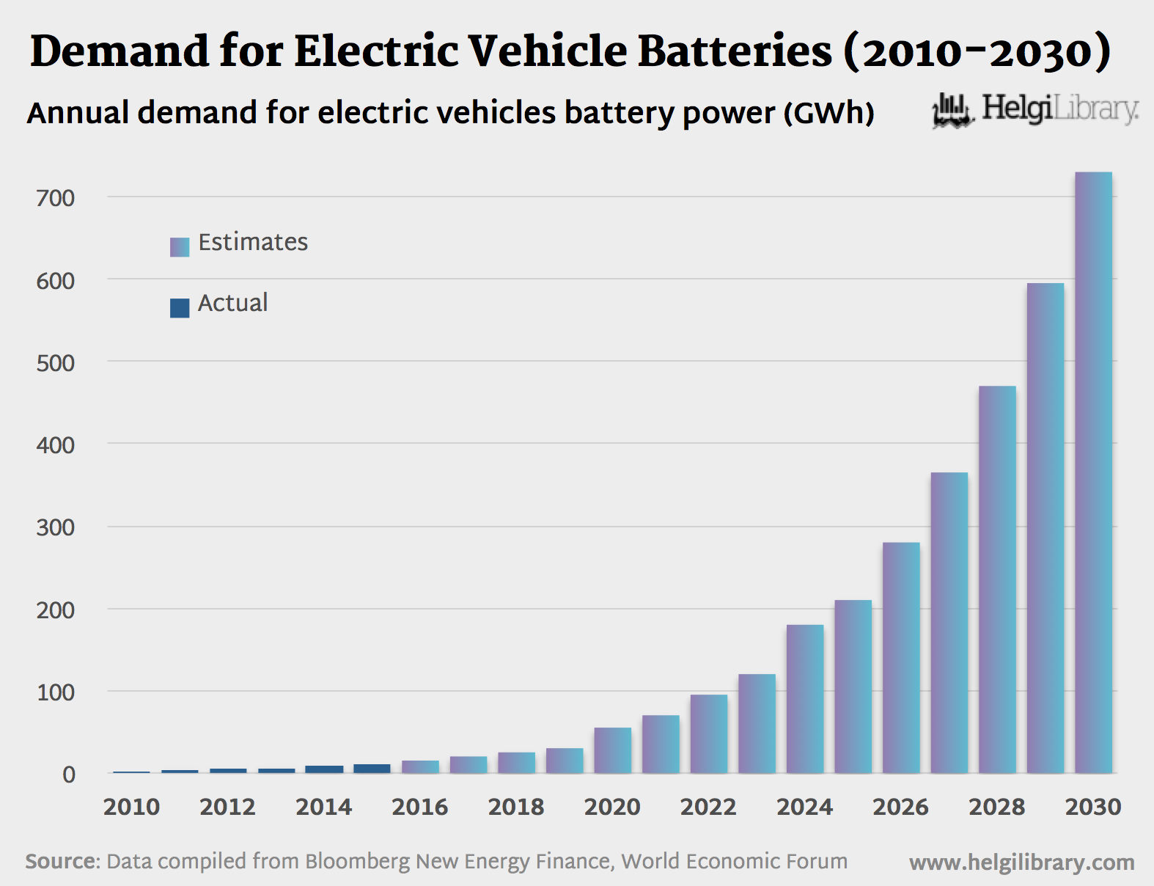

A graph showing demand for electric vehicle batteries

Secondly, the convenience of charging at retail locations can attract new customer segments to electric cars. People who may not have easy access to home charging infrastructure such as those living in apartments or urban areas may find electric cars more appealing. This expansion of the customer base can also contribute to higher demand.

The relationship between charging station availability and electric car demand using a simple supply and demand curve can be illustrated. As charging station availability increases the demand for electric cars is expected to rise. This graphical representation is based on the premise that consumers are more inclined to purchase electric cars when the infrastructure needed to support them is readily available.

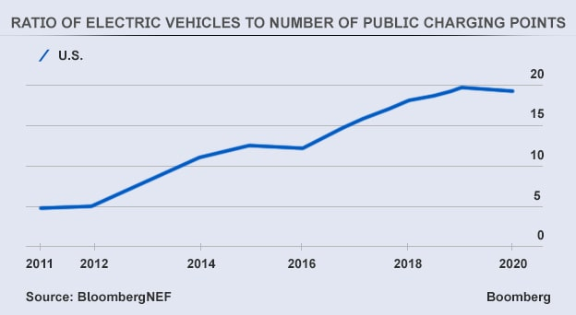

A curve showing the demand of electric vehicles to charging station

In conclusion, the installation of charging stations by a major retailer in 120 cities is a strategic move that recognizes the potential influence of charging station availability on electric car adoption. By analyzing this impact, it addresses range anxiety, attracts new customer segments and ultimately leads to higher demand for electric cars. The graphical representation further demonstrates the positive relationship between charging station availability and electric car demand.

**References**

Litman and T. (2013) *Electric Vehicle Charging Infrastructure Planning. Victoria Transport Policy Institute.*

**Exercise 4**

**Analyzing Investment Risk: ABC Ltd Stock**

Maria is in the process of reviewing potential stocks to include in her investment portfolio with One of the key criteria been considered to be risk and she follows a rule of only investing in stocks with a standard deviation below 10%. A diversified manufacturer of pet products meets this criterion to assess ABC Ltd. Maria needs to calculate the average return and the standard deviation of ABC Ltd's stock for the period from 2013 to 2015.

The annual returns for each year will first be computed to calculate the average return, by using the formula:

* Annual Return= (Ending Stock Price−Beginning Stock Price Dividend Paid)/Beginning Stock Price

**For year 2013:**

* Return= (36.50-35.00+3.50)/35.00

=5.00/35.00

≈0.1429 or 14.29%

**For the year 2014:**

Annual Return= (34.50-36.50+3.50)/36.50

=1.50/36.50

≈0.0411 or 4.11%

**For the year 2015:**

Annual Return= (35.00-34.50+4.00)/34.50

= 4.50/34.50

≈0.1304 or 13.04%

**Average Return= Sum of Annual Returns/Number of years**

= (0.1429+0.0411+0.1304)/3

≈ 0.1048 or 10.48%

1. **Determining the standard deviation;**

Calculate the differences between each year's annual return and the average return.

**For 2013:** 0.1429−0.1048=0.0381

**For 2014:** 0.0411−0.1048=−0.0637

**For 2015:** 0.1304−0.1048=0.0256

1. **Square these differences:**

**For 2013:** 0.03822≈0.0015

**For 2014:** (−0.0637)2 ≈0.0041

**For 2015:** 0.02562 ≈0.0007

1. **Calculating the average of these squared differences:**

= (0.0015+0.0041+0.0007)/3

≈0.0021

1. **Getting the standard deviation**

Standard Deviation= $\sqrt{0.0021}$ ≈0.0459 or 4.59%

In the previous analysis, a comprehensive examination of ABC Ltd was conducted to assess its investment suitability based on risk. Maria, an investor, established a strict criterion allowing her to invest only in stocks with a standard deviation below 10%. To make an informed decision, the average return and standard deviation of ABC Ltd's stock for the three-year period spanning 2013 to 2015 was calculated.

**Average Return Calculation**

The first step was to calculate the annual returns for each year in the given period. The annual return for a year is defined as the change in stock price plus dividends divided by the beginning stock price.

The annual return as approximately 14.29% in 2013 and was approximately 4.11% in 2014. It then amounted to about 13.04% in 2015. These returns were then averaged to derive an average return of 10.48% for the three-year period.

**Standard Deviation Calculation**

* The next critical aspect of the analysis was the calculation of the standard deviation. The standard deviation measures the degree of variation or risk in the returns of a stock.
* The differences between each year's annual return and the average return was calculated. The difference was 0.0381, -0.0637 and 0.0256 for 2013, 2014 and 2015 respectively.
* These differences were then squared to accentuate their magnitudes. Squaring them turned the values positive and accentuated the significance of deviations from the mean and squared differences of approximately 0.0015, 0.0041, and 0.0007 for the respective years was obtained.
* To compute the average of these squared differences, the squared differences was summed and divided by the number of years. The average of squared differences amounted to roughly 0.0021.
* The final step was to find the square root of the average of squared differences, yielding the standard deviation of 4.59%.

**Interpreting the Results**

The average return of ABC Ltd's stock over the three-year period is approximately 10.48%. This figure indicates that on average, investors could expect this return on their investment in ABC Ltd.

The standard deviation is about 4.59%. A lower standard deviation indicates more predictable, stable returns, while a higher standard deviation implies greater variability or risk.

**Maria's Risk Criterion:**

Maria's criterion for investing in stocks was to select those with a standard deviation below 10%. Her choice stems from a desire to minimize risk in her investment portfolio.

**Maria's Investment Decision:**

Given that ABC Ltd's stock has a standard deviation of 4.59%, it falls comfortably below Maria's risk threshold of 10%. Therefore, based on her specified risk criterion, ABC Ltd's stock is a suitable choice for Maria's investment portfolio. The stock's relatively low standard deviation suggests that its returns are relatively stable and have less fluctuation compared to riskier investments. This aligns with Maria's risk-averse investment strategy.

**Exercise five**

**Evaluating Investment Choices: Asset A vs. Asset B**

ABC Ltd, a manufacturer of custom golf equipment faces a crucial decision regarding two potential investments, Asset A and Asset B. Each investment requires an initial outlay of $10,000 and they offer various rates of return associated with different scenarios, including pessimistic, most likely, and optimistic outcomes. To make an informed decision, ABC Ltd's management needs to calculate the range of potential returns for both assets and determine which investment is preferable for a risk-averse decision maker.

**Investment Details:**

Initial Investment: $10,000 for both Asset A and Asset B

**Calculating the Range:**

The range represents the difference between the optimistic and pessimistic annual rates of return for each asset. It reflects the extent of variability or potential risk associated with the investment.

**Asset A Range:**

Optimistic Return: 17%

Pessimistic Return: 13%

Range = Optimistic Return - Pessimistic Return

Range = 17% - 13%

Range = 4%

**Asset B Range:**

Optimistic Return: 23%

Pessimistic Return: 7%

Range = Optimistic Return - Pessimistic Return

Range = 23% - 7%

Range = 16%

Interpreting the Results:

Asset A Range: 4%

Asset B Range: 16%

The range calculation shows that Asset B has a significantly higher range (16%) compared to Asset A (4%). This means that the potential variability in returns is much more pronounced for Asset B. A larger range suggests higher risk and a greater level of uncertainty regarding the investment's performance.

**Risk-Averse Decision:**

A risk-averse investor approaches investment decisions with a primary focus on risk mitigation. Minimizing the likelihood and impact of unfavorable outcomes is of utmost importance. For such an investor, the choice between Asset A and Asset B is clear.

A risk-averse decision maker prefers to minimize risk while seeking a reasonable return on investment. In this situation, with Asset B having a much larger range and a pessimistic return of 7% which is substantially lower than the initial 15% investment, it introduces a significant element of risk. Asset A on the other hand, exhibits a narrower range and a pessimistic return closer to the most likely return of 15%.

Therefore, for a risk-averse decision maker, Asset A is the more preferable choice over Asset B. Asset A's more predictable and less variable range aligns with the objectives of a risk-averse investor who aims to minimize potential loss and achieve stable returns.

**Conclusion:**

This analysis underscores the importance of considering not only expected returns but also associated risk when making investment decisions. By calculating the range for Asset A and Asset B, ABC Ltd can make an informed choice that aligns with its risk tolerance and financial goals. In this scenario, the risk-averse decision maker is better off selecting Asset A due to its narrower range and lower risk profile.

The calculated range provides valuable insight into the variability and potential risk associated with each investment allowing organizations like ABC Ltd to make well-informed investment decisions. By opting for the less risky alternative, ABC Ltd can develop a more secure and reliable investment strategy.